**ls command:**

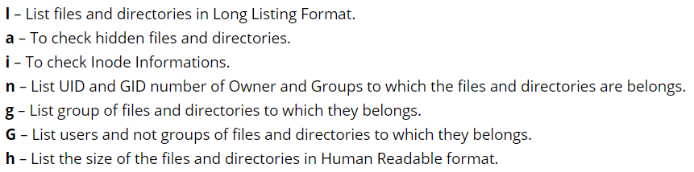

* **ls** ### List Files and Directories

You can use ls command with argument **-l** to get more advance information related files and directories like Permissions, Owner, Group, Size, Created and Modified month, date and time, file name…etc…

* **ls -l** # Long Listing of Files and Directories

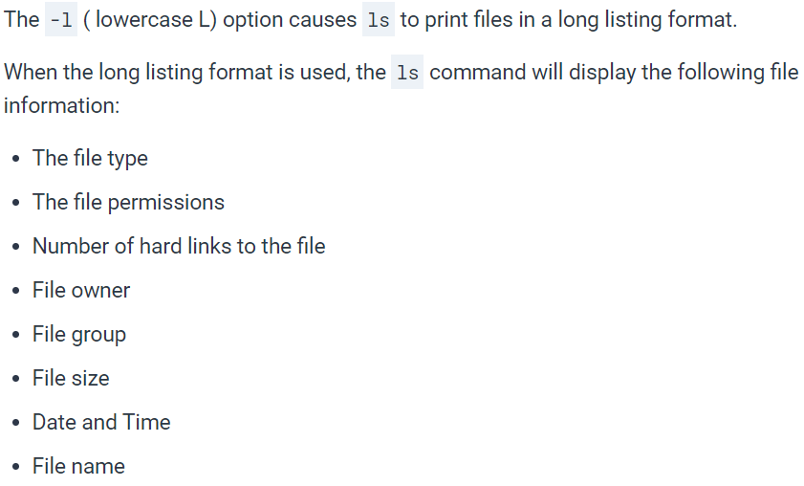

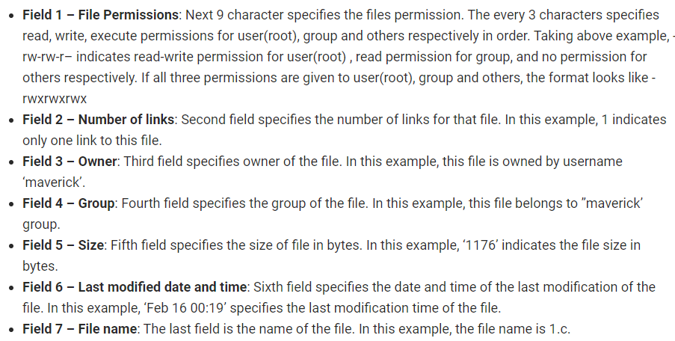

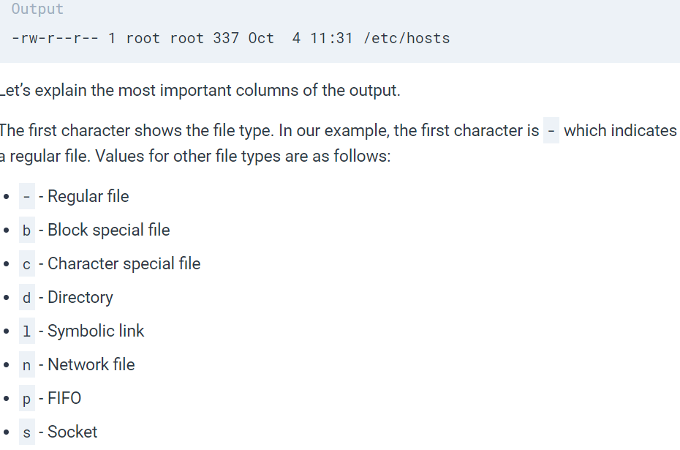

To list details of a particular file, refer the below command.

* **ls -l file.txt**

To list the content of a particular directory, refer the below command.

* **ls -l /mydata/**

You can check hidden files and directories by using Linux ls command with argument **-a**.

* **ls -a**

To check inode number of files and directories use ls command with option **-i.**

* **ls -i**

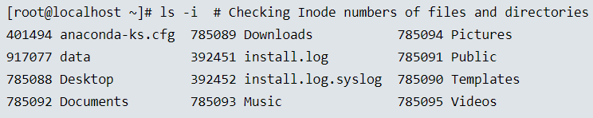

OR you can use the **-i** argument with -l as shown on below command.

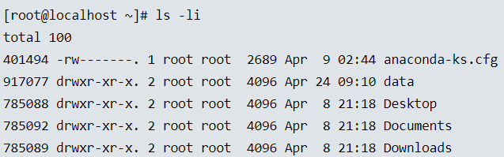

ls command with argument **-o** will show owner of the files and directories and will not show the groups.

* **ls -o**

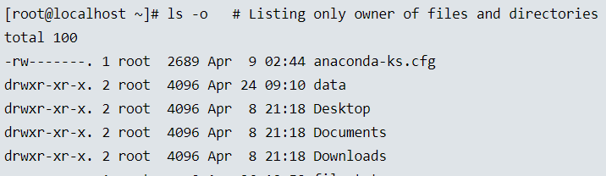

Linux ls command with option **-m** will list the files and directories separated by comma.

* **ls -m**

you can list directories recursively using Linux ls command with the argument **-R**. Recursively means it will list all the directory with is all subdirectory in a tree format.

* **ls -R**

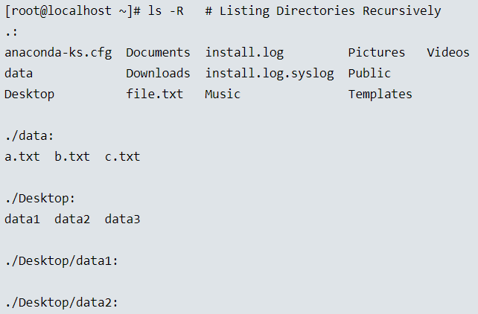

ls command with **~** will list the files and directories of home directory.

* **ls ~**

You can sort the files and directories by its size using ls command with argument **-S**.

* **ls -lS**

The above command lists the files with bigger size on the top. We can use **“r”** if we want to change that order

* **ls -lSr**

we can also use the below command to list the files based on the size recursively in human readable format.

* **ls -lhSr**

ls command with option **-h** will list the size of the files and directories in Human Readable format for Example 20K (20 KB), 15M (15 MB).

* **ls -lh**

ls command with option **-n** will show the UID (User ID) and GID (Group ID) numbers of file and directory.

* **ls -ln or ls -n**

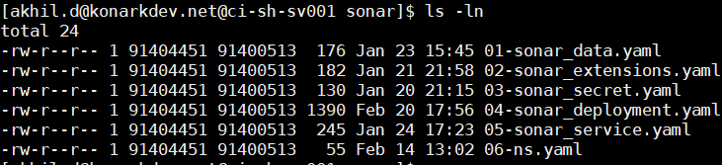

If you want to list only Owner of the files and directories to which they are belongs and not groups, then use Linux ls command with argument **-G.**

* **ls -lG**

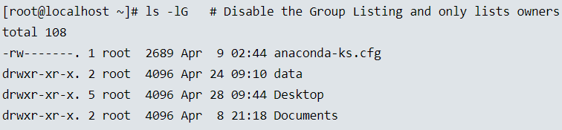

ls command with **-g** will list the group of the files and directories to which they are belongs.

* **ls -lg**

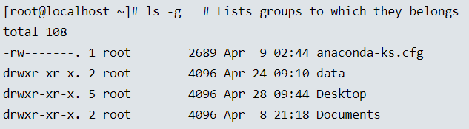

The following command with ls **-r** option display files and directories in reverse order.

* **ls -r**

With combination of **-ltr** will shows latest modification file or directory date as last.

* **ls -ltr**

ls command with **-F** will list the directories with a /at end. Refer the sample output below.

Instead of doing the ‘ls -l’ and then the checking for the first character to determine the type of file. You can use -F which classifies the file with different special character for different kind of files.

* **ls -F**

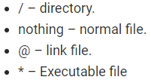

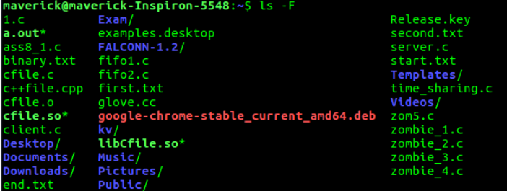

Check version of ls command.

* **ls - -version**

**-ld** parameter used to display the information of a directory

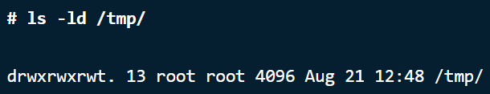

If we run it for current directory



For more reference on Linux ls related commands and its arguments you can run below commands in your linux system.



There is no way for listing only the files in a directory using the ls command. There could be different kinds of files in a directory. It depends on the way we need to filter.

If we want to list only text files, we can use the below command

* **ls -ltr *.txt**

if we want to eliminate the directory and display remaining content in a directory. May be we can do that with find command